Parish Councillors are duly summoned to attend a Briercliffe with Extwistle Annual Parish meeting to be held Thursday 8th May 2025 at 7:30pm at the Community Centre, Jubilee Street
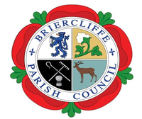
Members of the public are invited to attend.

BRIERCLIFFE WITH EXTWISTLE PARISH COUNCIL
ANNUAL PARISH MEETING
Thursday 8th May 2025 7:30pm

Business:
- Welcome
- Apologies for absence
- Declaration of Pecuniary Interests and Complete Register of Interest Forms
- To confirm or otherwise the minutes of the last Annual Parish Meeting on Tuesday 30th May 2024
- Chair’s Report for the past year.
- Finance Report
- To approve the date for the next Annual Parish meeting to be held Monday 14th May 2026
Cllr Gordon Lishman
Chair

